Determination of the Resistance of Grounding Systems Trough Regression Methods Using a Hemispheric Model
Felix Raul Alcantara
Member IEEE
Lima, Perú
felix_raul_alcantara@ Hotmail.com

Abstract—A new procedure for the determination of the resistance of grounding systems when using the fall-of-potential method, is presented. Usually, this task is done plotting the measurement points versus the distances to get a curve from which the value of the resistance is deduced visually or through a curve fitting technique. For doing this any method of fitting a function to measurement data is used. This kind of fitting procedure is a pure mathematical one, which ignores the physical conditions of a particular system.
The proposed procedure uses a function, which is derived from the fall-of-potential equation using hemispheric electrodes, taking in consideration the dimensional and soil characteristics of the grounding system.
This function has been compared to the polynomial and a constant function, finding better results in simulation and actual cases.

Keywords— Ground resistance measurement, Fall-of-Potential method, hemispheric electrodes, least-squares curve fitting.

introduction
The measurement of grounding systems is usually made following the directives of the related standards [1, 2, 3, 4], the main recommendation of them is to choose a distance between the ground and current electrodes that permits an accurate reading of the resistance. These distances are:
IEEE 80 Large enough
IEEE 81 >5x$L_{D}$
IEEE 81.2 >6.5x$L_{D}$, for large grounding systems.
BS 7430 50 m, for small or single electrode.
(say, $L_{D}$ = 2.5 m, then 20x$L_{D}$)
100 m, for $L_{D}$ = 5 m, (i.e. 20x$L_{D}$)
150 m, for $L_{D}$ = 10 m, (i.e. 15x$L_{D}$)
200 m, for $L_{D}$ = 20 m, (i.e. 10x$L_{D}$)
$L_{D}$: largest dimension of the grounding electrode .
The process of measurement of the grounding resistance through the fall-of-potential method (FOP) is, in practice, accomplished through the following procedures:

- Simplified. The point of measurement $x_{0}$, is in all cases, located at 61.8 % of the current electrode distance. This is known as the “61.8 % rule” [4][7], which is recommended in most of the standards, for small and in some cases large systems.

- Exact. The point of measurement is determined for each particular arrangement using specialized computer programs or an approximated procedure using a hemispheric model [5]. In this instance, data of soil resistivities and characteristics of the grounding system must be known to calculate the correct measurement point.

- Graphic. The measurement is made by moving the potential electrode in steps, away from the
grounding electrode under test and plotting the apparent resistance readings against the distances, to find a flat portion on the graph that indicates the value of the resistance. However, if the distance to the current electrode is not long enough, or the soil is non-uniform, there will be no flat portion on the resistance versus distance curve and, therefore, the method cannot be used.

- Curve fitting. The data of the last method is used to find a curve that best fits this data through a least-squares regression method. The curve could be of any type, but generally a higher degree polynomial is used.

The proposal of this paper is to make the curve fitting applying a function that is derived from the FOP equation, which has been generated using hemispheric equivalent electrodes, according to the method described in [5] and [6]. This function, contrary to the polynomial one, is not purely mathematical, but has physical meaning and takes into account all the parameters of the grounding system.

This paper was sponsored by the Association Safe Energy NGO.

I. THEORY

Derivation of the Measurement Curve

Fig. 1. Fall-of-Potential method for two hemispheric electrodes.

From Fig. 2, it is possible to write the equations of potentials for the FOP arrangement considering two hemispheric electrodes [5,6], the potential at electrode $E$, is:

$U_{E}=U_{E}^{E}+U_{E}^{C}$ (1)

Where, $U_{E}^{E}$ is the potential rise of electrode $E$ resulting from its own current $I$, $U_{E}^{C}$ is the potential on $E$ caused for the current at$C$.

Similarly, the potential at point P, located at a distance $x$ from E, will be:

$U_{P}=U_{P}^{E}+U_{P}^{C}$ (2)

The voltage measured by the FOP method is:

$V_{x}=U_{E}-U_{P}$ (3)

${{V_{x}=U}_{E}^{E}+U_{E}^{C}-U}_{P}^{E}-U_{P}^{C}$ (4)

The Potential at a point on the soil surface of a two-layer soil, at a horizontal distance $x$ from a point current source is [7]:

$U=\frac{ {}_{1}I}{2} \left[\frac{1}{x}+2\sum_{n=1}^{n=∞}{\frac{K^{n}}{{\left\{x^{2}+{\left(2nh\right)}^{2}\right\}}^{\frac{1}{2}}}}\right]$ (5)

Where,

$U$ Potential of a point, $V$.
$K$ Coefficient of reflection. $K=\left(ρ_{2}-ρ_{1}\right)/\left(ρ_{2}+ρ_{1}\right)$.
$ρ_{1}$ Resistivity of the upper layer of soil, Ω-m.
$ρ_{2}$ Resistivity of the lower layer of soil, Ω-m.
$h$ Height of the first layer, m.
$I$ Current dissipated by the point source. A.

we can write (5), in this way:

$U=F\left(x\right) I$ (6)

Where,
$F(x) =\frac{ {}_{1}}{2} \left[\frac{1}{x}+2\sum_{n=1}^{n=∞}{\frac{K^{n}}{{\left\{x^{2}+{\left(2nh\right)}^{2}\right\}}^{\frac{1}{2}}}}\right]$ (7)

From (5), (6) and (7) and the current equal to unity value, (4) can be written as the apparent or calculated resistance:

$R_{c}=F\left(r\right)-F\left(d\right)-F\left(x\right)+F(d-x)$ (8)

Several plots of this function are shown in Fig. 3. The use of (8) for the curve-fitting of measurement data will be called the technique of Potentials derived from Hemispheric Electrodes (PHE).

Non linear least-squares curve fitting

In the last section, the function $Rc \left(v; x\right)$ was derived, which provides a prediction of the resistance value at the distance $x$ from the ground electrode, for appropriate values of the four-dimensional parameter vector $v(ρ_{1}, ρ_{2}, h, r_{1})$,

$Rc \left(ρ_{1}, ρ_{2}, h, r_{1}; x\right)$ (9)

The parameter vector $v$ is chosen, so that this model best agrees with the field measurements. A good way to measure the difference between the calculated values and the measurements is the following least-squares function¸ which sums the squares of the residuals of calculated and measured values at each $x_{j}$,

$ψ\left(v; x\right)= \sum_{j=1}^{m}{{\left\lceil ({Rm}_{j}- {Rc}_{j})/{Rm}_{j}\right\rceil }^{2}}$ (10)

Where, ${Rm}_{j}$ is the vector of measured resistances, and $m$ the number of measurements. The objective function $ψ$ of a least-squares nonlinear optimization problem subject to constraints can then be stated as,

Minimize $ψ\left(v; x\right)$ (11)

This problem can be solved using any of the numerous existing least-squares regression methods.

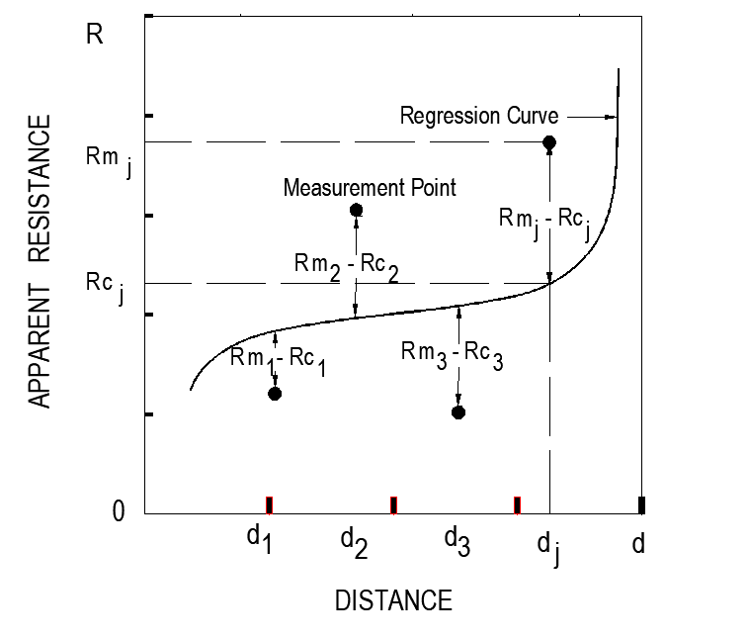
Fig. 2. The graphic meaning of the Least squares Optimization

Graphically, each term in (11) represents the square of the vertical distance between the curve $Rc \left(v; x\right)$ plotted as a function of $x,$ and the point (${x_{j }, Rm}_{j}$), for a fixed choice of the parameter vector $v$, as can be seen in Fig. 2.

The minimizer $v^{*}$ of the least-squares problem is the parameter vector for which the sum of squares of the lengths of the dotted lines in Fig. 2 is minimized. Having obtained $v^{*}$, it can be used $Rc \left(v^{*}; x\right)$ to calculate the resistance and the correct measurement point $x_{0}$, which is given by the inflection point of the curve. It assumes that distances$x$are known to high accuracy, while the measurements ${Rm}_{j}$ may contain more or less random errors.

It is also assumed, that the measurement error of any data point included in the fit, follow the same normal distribution having the same mean (µ = 0) and the same standard deviation (σ). There could be, however, scenarios where σ varies considerably over the range of measured data. Big resistance variations can be attributed to small local discontinuities in the soil, or to inaccuracies in the measurements due a number of factors such as stray currents in earth or inadequate sensitivity of the measuring equipment. The presence of buried pipes or other metallic structures close to the surface is also a typical cause of sudden changes in the measured values.

These abnormal measurements or outliers may be expressly neglected, but the chosen function $ψ\left(v, x\right)$ being relative to the same measured data, provides a good and practical weighting scheme that reduces errors due to abnormalities.

Generation of artificial data points

Artificial data points will be generated through a function available in many software packages, which generates random numbers from a normal or Gaussian statistical distribution,

$RAND(m_{j},n)$ (18)

Where,
$m_{j}$: number of measurement points.
$n:$ number of $m_{j}$ series generated.

This function generates a sequence of numbers that are normally distributed with a mean of $μ=0$ and a standard deviation of $σ=1$. The following formula can be used to generate a normal distribution with a different mean (${Rm}_{j}$) and standard deviation (s) [8] . The perturbed resistance will then be:

$R_{p}$= ${Rm}_{j}+s * RAND(m_{j},n)$ (19)

The standard deviation of the random data will be assumed, only for this simulation and not being based on actual survey data, to be:

$s=0.1*{Rm}_{j}$ (20)

The curve fitting procedure

From fig. 2 it is appreciated that only when the distance d is 10xL or greater, L being the side of the square grid, there is a horizontal part on the curve, and the graphical method for finding the resistances can then be applied. For shorter distances d it is not possible to deduce the corresponding resistance visually, and besides, it would depend on the subjective viewpoint of the person drawing the curve.

Therefore, a numerical objective curve fitting method becomes necessary. One way to do this is to derive a curve that minimizes the residuals between the data points and the curve. A technique for accomplishing this objective, has been described in section I. B.

Two kind of curves will be used for the fitting procedure, one is a third-degree polynomial function, of the form $ax^{3}+bx^{2}+cx+d$, chosen considering that it only has one inflection point that will indicate the value of the resistance on the $y$ axis and the correct measurement point ($x_{0})$on the $x$axis; and the other is the function given in (8), which was called the PHE technique.

Apart from the two mentioned techniques, there is the “61.8 % Rule” described in [4] and [7] to determine the resistance of a system by the FOP method. The third degree polynomial and the PHE function can both give us the inflexion point mathematically, while the 61.8% rule, assumes a constant measurement point in all cases independently of the inflexion point. The three methods will be used for the following analysis.

III. simulation of measurements and curve fitting

Case I: 30x30m Grid

A four-mesh grounding grid of 30x30 m, conductor radius of 0.01 m, buried at a depth of 0.5 m, presented in [6] will be analyzed to show the simulation of measurements and curve fitting procedure. The resistance versus distance curves for this system is given in Fig. 2 for the parameters $K, h$ and several values of $d$, as indicated.

The minimum practical short distance of $d=$2x$L$, in this case 60 m, will be chosen for this analysis, because frequently, there is not enough space for making these measurements using longer leads. The curves for this analysis are shown in Fig. 3, for $K=0.0, K=±0.7$with $h=2 m$ for non-homogeneous soils.

From the theoretical curves of resistance versus distance, data will be generated as explained in section III. C, with $n=100,$ i.e., 100 for each measurement point, and $m_{j}=9,$giving a total of 900 points. For each sequence of 9 measurement points a fitting curve will be found using the least-squares technique described in III. B. In Fig. 5 it can be seen the theoretical curve and all the data generated for $K=0$. In Table I the results of this simulation giving the resistances and $x_{0}$points, are presented.
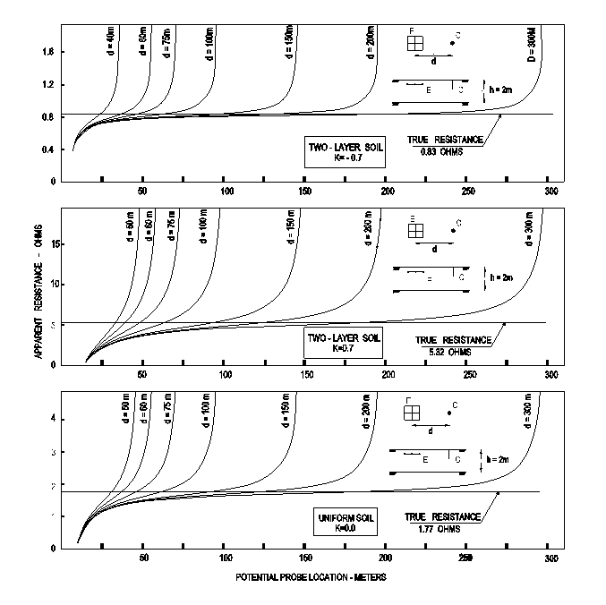

Fig. 3. Resistance versus distance curves for various d and K.

TABLE I. RESULTS OF SIMULATION 30x30m GRID

Coeff. of Reflection | K = 0 |  | K = 0.7 |  | K = -0.7
Parameter | R | Xo % | R | Xo % | R | Xo %
Theoretical values (T) | 1.774 | 61.80 | 5.320 | 65.72 | 0.833 | 60.02
Avg. Fitted  Values (F) | 1.745 | 61.90 | 5.311 | 66.23 | 0.812 | 60.38
Standard Deviation | 0.07 | 0.028 | 0.573 | 3.14 | 0.04 | 2.54
%Error =  (T-F)/T*100 | 1.6 | -0.2 | 0.2 | -0.8 | 2.5 | -0.6

From table I it can be seen that the errors yielded by this fitting method are, for this simulation, in the range <-0.6, 2.5> per cent which are acceptable. In Fig. 4 it is shown a histogram for the $K=-0.7$ case. As can be seen, the data of resistances determined also follows a Gaussian distribution.
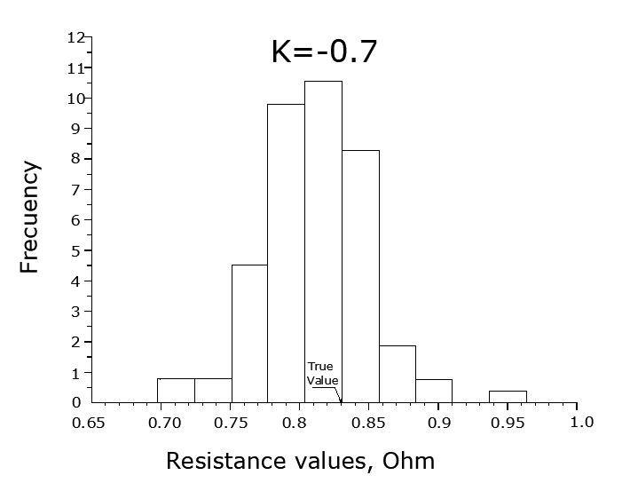
Fig. 4 Histogram of resistances determined in the simulation
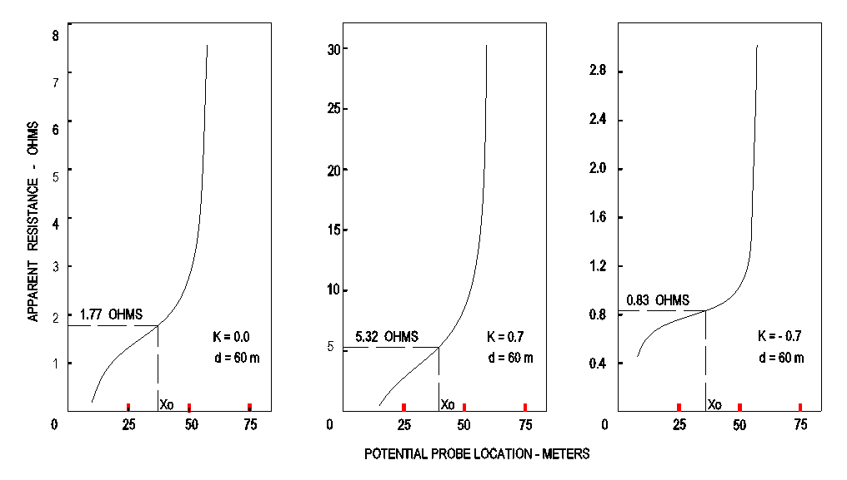

Fig. 5. Resistance versus distance curves for d = 60 m.

Fig. 6 Random Data Generated for the simulation.

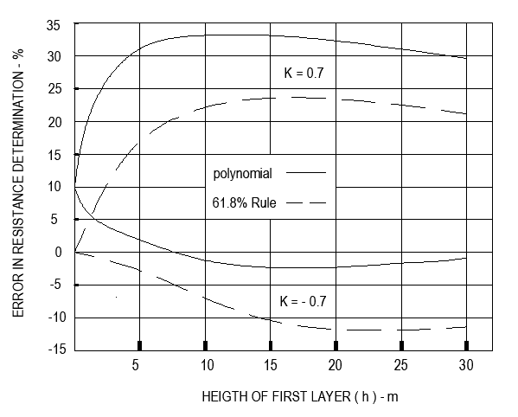

Fig. 7 Error in the determination of resistances of the system.

Errors in the fitting procedures versus changes in the heigth of the first layer of soil (h).

For the same grounding grid of the last section, and considering that from the FOP equation using hemispheric electrodes the theoretical correct measurement point can be obtained [5] and, therefore, the error in the determination of
the resistance through the PHE procedure would be zero, the theoretical errors produced by the 61.8 % rule and the polynomial procedure will be found in this simulation for different values of $h$ varying from 2 to 30 m. Obviously, the zero error in this simulation refers only to the error by the procedure itself , the other kind of errors are still present. In Fig. 7 the errors in the values of the resistance are given. There it can be seen, that the errors produced by the polynomial procedure are always higher than the errors of the 61.8 % rule, particularly more for $K=0.7.$

III. comparative study

Comparison of the PHE, the 61.8 % rule and polynomial techniques. Grounding grid case.

In [7], a series of test were made at an actual substation of 25x30 m to find the resistance of the grounding system using the 61.8 % rule. The curves related to these measurements are shown in Fig. 8, along with the corresponding points obtained applying the two other techniques. As can be seen, these points are very near to the measurement curves but what is important is the point of inflexion of theses curves, because it gives us the value of the true resistance of the system; as it is shown in the figure for the measurement for $d=52 m.$ The shape of the curves corresponds typically to a measurement made at short distance of the current electrode, in this case from (1.3 to 3.3)x$L_{D}$ compared to the required 6.5x$L_{D}$ of [3] ,which is 254 m.

In Table II the values of the resistances determined for the different current electrode spacings are given. The difference between the value of the resistances is 8 % applying the 61.8 % rule, and 15% for the polynomial respect to the PHE technique.

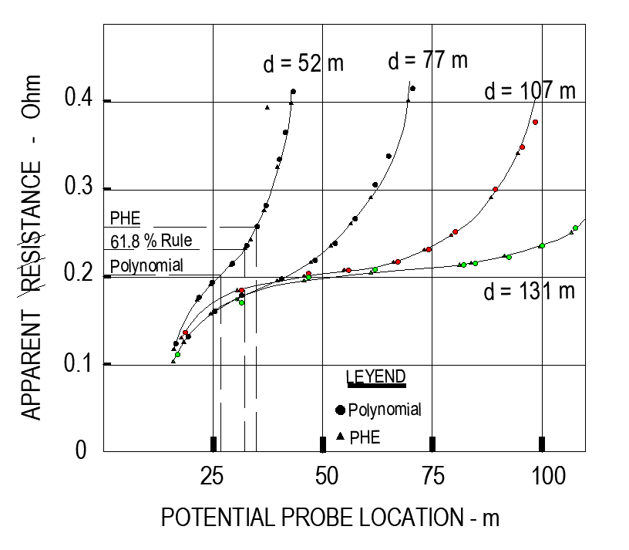
Fig. 8 Actual measurements on 25x30m substation [7].

TABLE II. RESULTS OF STUDY ON ACTUAL CASE

DISTANCE d, m | "61.8 % RULE" |  | POLYNOMIAL |  | PHE
 | R | Xo, % | R | Xo, % | R | Xo, %
171 | 0.231 | 61.8 | 0.202 | 51.27 | 0.256 | 65.5
251 | 0.216 | 61.8 | 0.190 | 48.52 | 0.252 | 73.0
351 | 0.216 | 61.8 | 0.206 | 48.63 | 0.234 | 55.2
431 | 0.213 | 61.8 | 0.209 | 52.17 | 0.209 | 55.6
Average | 0.219 | 61.8 | 0.202 | 50.15 | 0.238 | 62.3
Difference % | 8 | 1 | 15 | 20 | - | -

IV. CONCLUSIONS

It has been confirmed that the 61.8 % rule is an extremely simplified procedure only suitable for small systems in homogeneous soils. On the other hand, the polynomial method has been shown not being accurate in most cases, not even in homogeneous soils and yields higher errors than the 61.8 % rule.

The accuracy in determining the earth-resistance value by the FOP method can be improved using the PHE technique. Also, it permits to carry out measurements using shorter lead distances of the electrodes, which is useful when buildings or other obstacles difficult the measurements.

It has been shown that the PHE technique can be useful as a simple and practical tool to determine the resistance of a grounding system by the FOP method, using only an ordinary spreadsheet for making the necessary calculations, in an inexpensive way.

References

- IEEE Guide for Safety in AC Substation Grounding. IEEE Std 80-2012.
- IEEE Guide for Measuring Earth Resistivity, Ground Impedance, and Earth Surface Potentials of a Ground System, IEEE Std. 81-2013.
- IEEE Guide for Measuring Earth Resistivity, Ground Impedance, and Earth Surface Potentials of a Ground System, IEEE Std. 81.2-2013.
- BS 7430:2011+A1:2015, Code of Practice for Earthing, British Standards Institution.
- Félix Raúl Alcántara, “An Approximated Procedure to Find the Correct Measurement Point in the Fall-of-Potential Method”. 2018 IEEE PES Transmission & Distribution Conference and Exhibition – Latin America (T&D-LA). IEEE Conferences.
- Félix Raúl Alcántara, “Simulation of Measurements of Resistances of Grounding Systems by a Simple Hemispheric Model”. 2019 Intercon. IEEE Conferences.
- G. F. Tagg. Earth Resistances. George Newnes Limited. London 1964.
- Steven C. Chapra. Applied Numerical Methods with Matlab for Engineers and Scientists— 3th ed. McGraw-Hill, 2012.

